**NS3 Task**

**128**

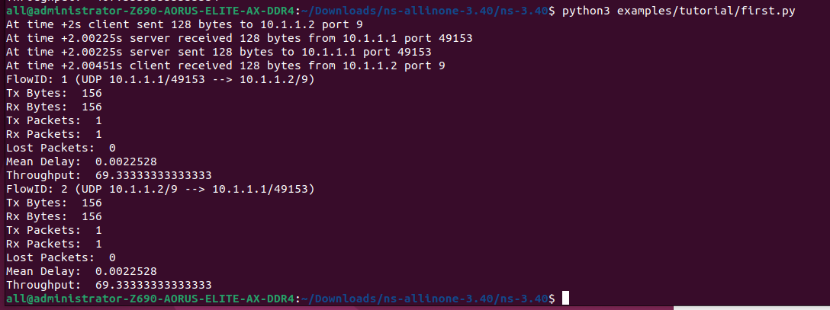

**256**

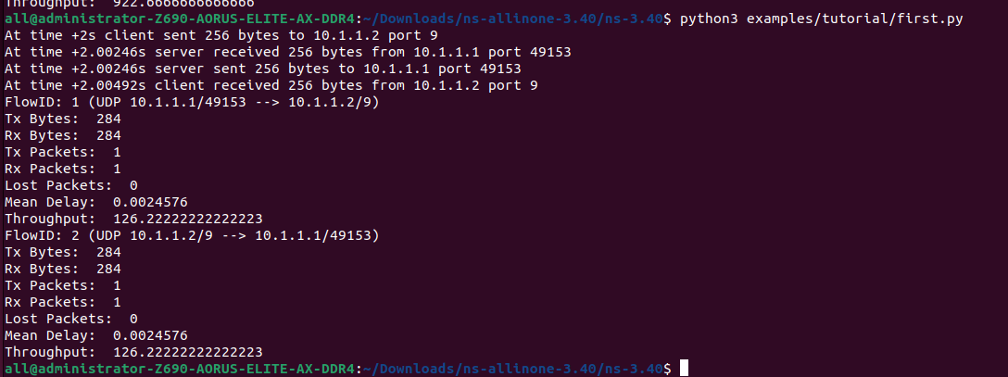

**512**

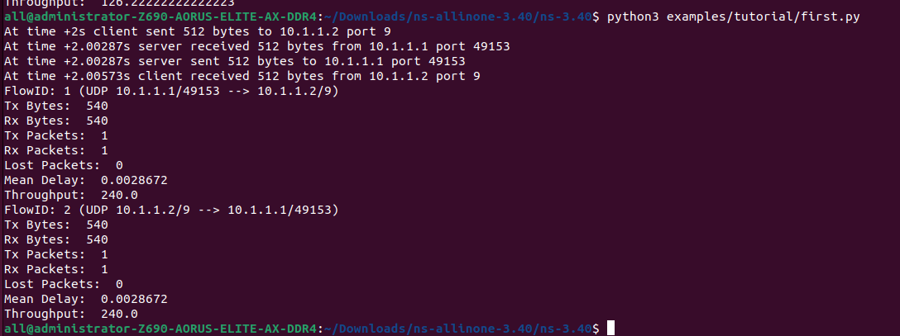

**1024**

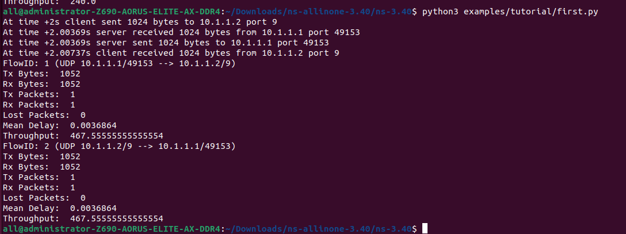

**2048**

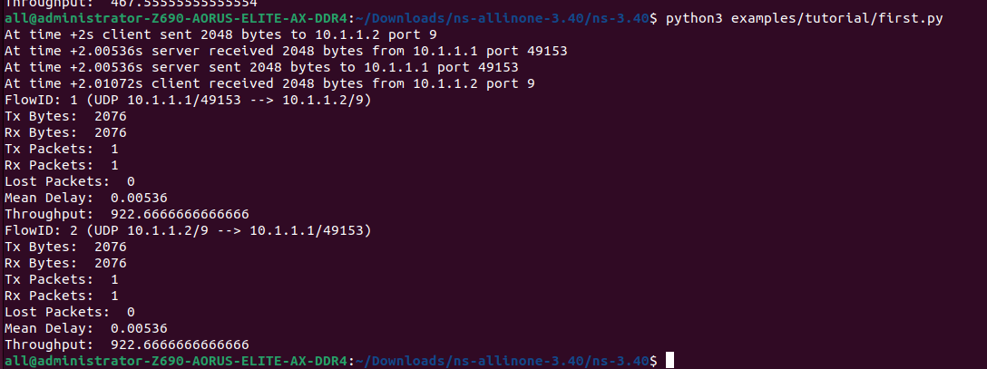

**Table:**

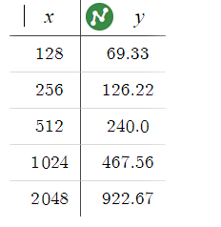

**Graph:**

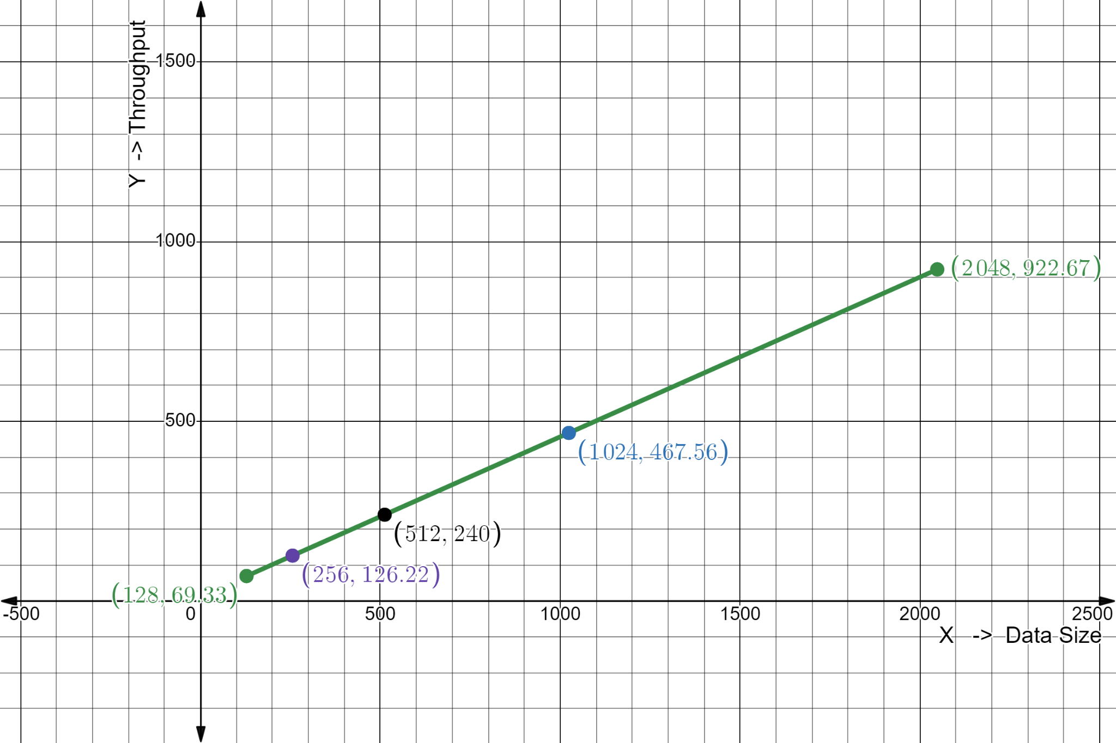

**Description:**

This graph shows how throughput increases as the data packet size increases. The throughput grows more rapidly as the data packet size increases. At small data packet sizes (128 and 256), the increase in throughput is relatively modest. As the data packet size increases (512, 1024, and 2048), the throughput increases significantly.